**GAP – EDI Rx 852, 867 - Business Requirement**

| **Program Name:** | GAP | **Program Manager:** | Michelle Hood |
| --- | --- | --- | --- |
| **Project Name:** | EDI Rx 852,867 in SupplierNet | **Project Manager:** | David Shapiro |
| **Project Number:** |  | **Account Unit:** |  |
| **Sponsor:** |  | **Business Owner:** | Jeff Nicolai |

**Document Version Control**

| **Date** | **Version #** | **Describe Revision(s)** | **Author(s)** |
| --- | --- | --- | --- |
| 10/10/2012 | 1.0 | Initial Version | Cognizant |
|  |  |  |  |
|  |  |  |  |
|  |  |  |  |

**Document Overview**

This document identifies the business requirements for the Rx EDI 852 and 867 on Supplier Net. Other requirement documents such as functional and technical will be created based on these business requirements.

**Business Objectives:**

The Stores and DC’s will send the Rx POS/Inventory details and Rx Product Transfer and Resale detail to the Mainframe systems. The Mainframes process this information and creates Product Activity Reports (EDI 852) and Product Transfer and Resale Reports (EDI 867) and sends them across to the different vendors.

Non-EDI vendors will not be able to comprehend the Rx EDI 852 and 867 data. Currently the Pay on Scan vendors will be given an invoice based on the units sold as in the Rx Product Activity Data report. Since they are Non-EDI vendors do not have an option to view the Rx EDI 852 and 867. In order to overcome this limitation vendors should be given an option to download the EDI 852 from Supplier Net in CSV format. The CSV files would be made available for download in win zipped format.

The Vendors can select the flavors of 852 that they can download from SupplierNet.

<Need to understand what the flavor/type of 867 we have are and what vendor can download from SupplierNet>

**Business Requirements**

| **BR ID #** | **Description** | **Requested**  **By** | **Priority** | **Category** |
| --- | --- | --- | --- | --- |
| 1 | **Rx Product Activity Data(852) on SupplierNet**   * Non-EDI Vendor and EDI Capable Vendors who are not capable of EDI 852 and 867 should be able download Rx 852 Report from SupplierNet in csv file format. * DC and DSD PO/ASN/Invoice Application will have the Provision for vendor to download it. |  |  |  |
| 2 | **Rx Product Transfer and Resale Report Data(867) on SupplierNet**   * Non-EDI Vendor should be able download Rx 867 Report from SupplierNet in csv file format. * DC and DSD PO/ASN/Invoice Application will have the Provision for vendor to download it. |  |  |  |
| 3 | **Rx 852 Flavor**:  Following Rx 852 flavors should be made available to vendor for Download  <Need to get it from Business> |  |  |  |
| 4 | **Rx 867 Flavor/Type**:  <Need to get it from Business> |  |  |  |
| 7 | **Alert to Vendor:**   * Vendor should receive an alert e-mail notifying that 852 or 867 data is available in SupplierNet * The vendors should receive an alert email at the end of the 3rd week indicating that the file will not be available after a week’s time. * The vendors should receive an alert email one day before the end of 4th week indicating that file will not be available after a day. |  |  |  |
| 5 | **Vendor Acknowledgement for Rx 852 and 867 Data:**   * SupplierNet should be able to send an acknowledgement (997) for 852 once vendor download the csv file. * Need to check if same acknowledgement code 997 can be reused. |  |  |  |
| 6 | **Download Time Frame and Purging:**   * Vendor should be allowed to download the 852 and 867 CSV file for a time period of 4 weeks. * The CSV file will be purged from the system after a period of 6 weeks. * Mainframe should backup the CSV file. |  |  |  |
| 7 | **Corporate User Reports for 852:**   * A report should be made available for the Corporate users to view the following details for the csv files in the SupplierNet for Rx 852. * Vendor Number * Flavor * Location * Period * Date for which the csv file was generated. * Date when the mainframe posted the data * Date when the SupplierNet received the Data * File Acknowledged by date * File Acknowledged By User ID * Last Downloaded date * Last Downloaded User ID * Similar report should be made available |  |  |  |
| 8 | **Corporate User Reports for 867:**   * A report should be made available for the corporate users to view the following details for the csv files in the SupplierNet for Rx 867.   <List of fields need to be decided> |  |  |  |
| 9 | **Capacity Requirement:** |  |  |  |

**Flow Diagram**



**Proposed Screen Changes in DC PO and DSD PO ASN application**

**Home Page-**

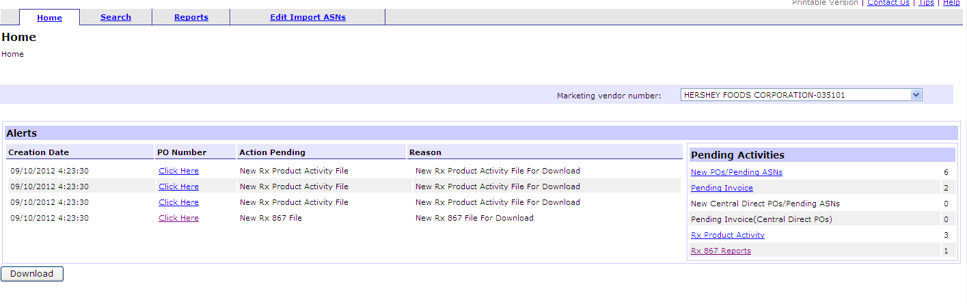

1. Vendors will be alerted of new Rx product activity report data(852) and product transfer and resale data(867) in the Alerts section of the home page.
2. When vendor click on the Click Here link of New Rx Product Activity File in Alerts section, the product activity reports page will open
3. When vendor click on the Click Here link of New Rx 867 File in Alerts section, the product transfer and resale reports page will open.
4. Pending Activities Section displays the list of Product Activity Reports and Product Transfer and Resale Reports that are yet to be downloaded.

When user clicks on the New Rx Product Activity Data link in Pending Activities, the Rx product Activity Reports page will open.

When user clicks on the New Rx 867 File link in Pending Activities from Home page, the Rx Product Transfer and Resale page will open.

**Rx Product Activity Reports**

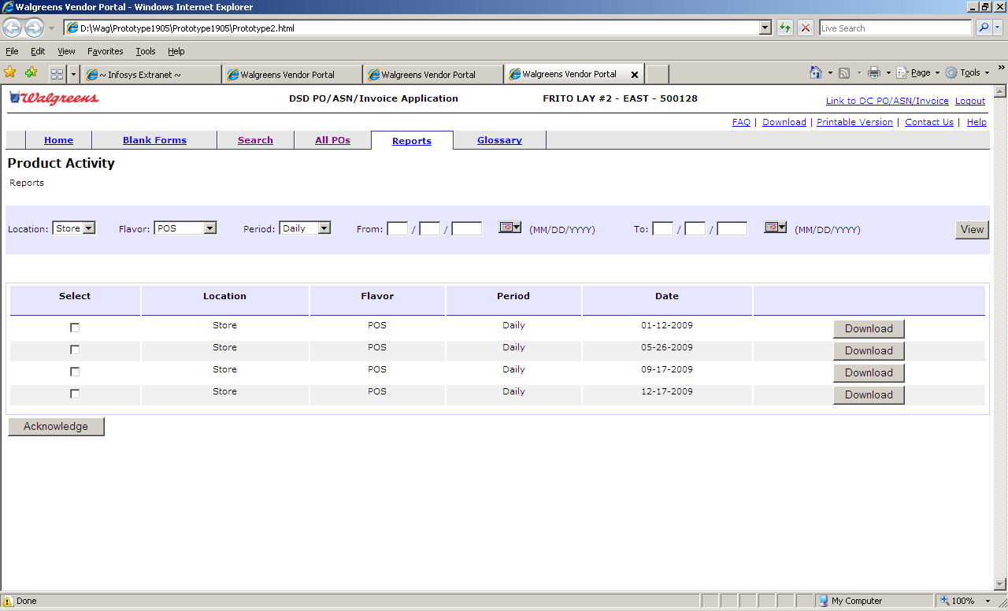

1. User can enter the following filter criteria.
   1. Location – <TO BE DECIDED>
   2. Flavor – <TO BE DECIDED>
   3. Period – All/Daily/Weekly
   4. From Date - The date from which the 852 details are to be searched.
   5. To Date – The date till when the 852 details are to be searched.
2. Once the user clicks the View button entering the values, the list of Rx 852 that are available satisfying the filter criteria will be displayed.
3. User can click the download button to download the corresponding csv file.
4. User can select the check boxes for the records and click on the Acknowledge button to send a functional acknowledgement (997) for the Rx 852.

**Rx Product Transfer and Resale Reports**

<Need to finalize the search criteria and search result fields to be displayed>

**SupplierNet Screen for Corporate User**

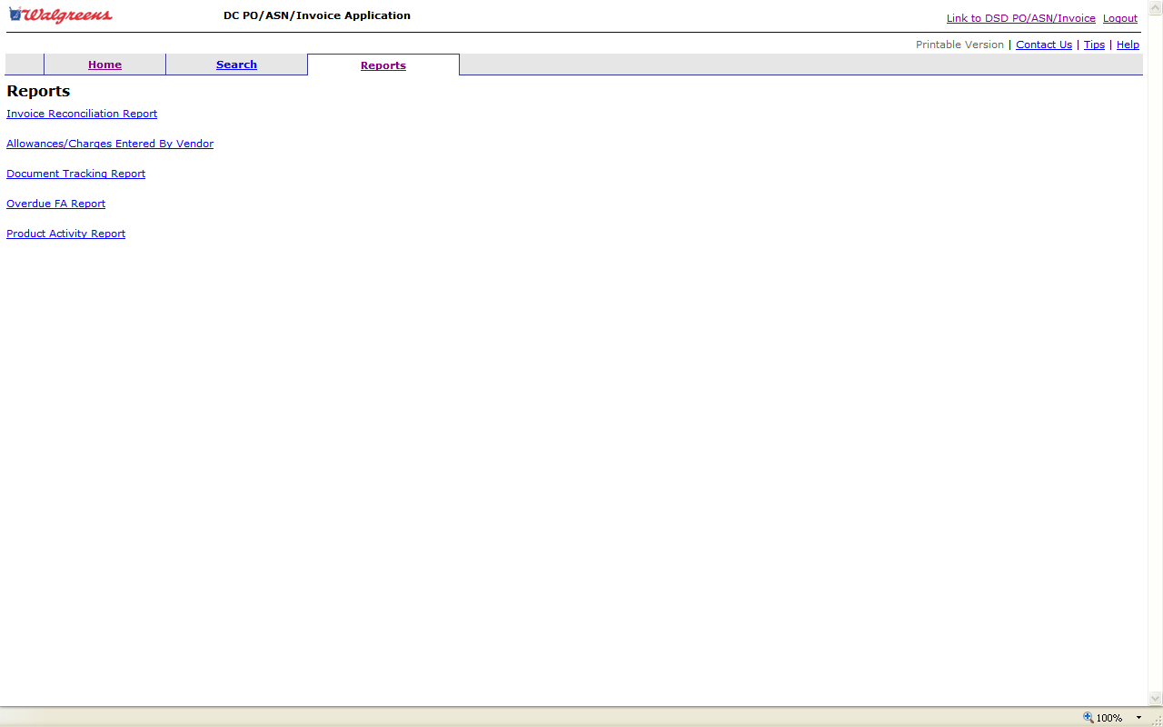

Rx Product Transfer and Resale Report

Rx Product Activity Report

Corporate User can login to Supplier Net and view reports –

1. Rx Product Activity Report (Rx 852)
2. Rx Product Transfer and Resale Report (Rx 867)

**Corporate Report – Rx Product Activity <Need to finalize the fields>**

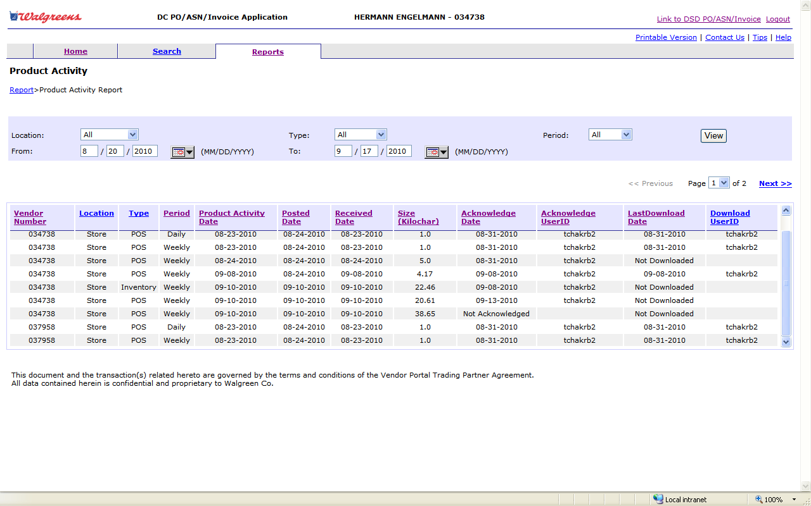

**Corporate Report – Rx Product Transfer and Resale Report**

<Need to finalize Report criteria and result fields>

**Dependency**

1. EDI Mainframe – Send the CSV files to supplier net with headers for Rx 852 and Rx 867.
2. EDI Profile should have these new transactions.

**Out-of-Scope & Exclusions:**

1. This implementation is restricted to only Rx 852 and 867. Existing 852 enhancements or defect fixing is not in the scope of this project.

**Implementation Strategy**

**Assumptions and Dependencies**

**Requirement Assumptions**

| **ID** | **Related BR ID#** | **Assumption Description** |
| --- | --- | --- |
| 1 | All | This implementation is restricted to only Rx 852 and 867. Existing 852 enhancements or defect fixing is not in the scope of this project. |
| 2 | All | Supplier doesn’t format or validate the received Rx 852 and Rx 867. |
|  |  |  |
|  |  |  |
|  |  |  |
|  |  |  |

**Requirement Constraints**

| **ID** | **Related BR ID#** | **Constraint Description** |
| --- | --- | --- |
| N/A |  |  |

**Requirement Dependencies**

|  |  |  |
| --- | --- | --- |
| RD 1.0 | EDI IT | EDI sends Rx 852 ,867 to Supplier Net |
| RD 2.0 |  |  |
| RD3.0 |  |  |

**Training and User Documentation Requirements**

**Business Requirements Approval**

The signature below indicates the individual has reviewed and approves all of the detailed business requirements with the exception of those listed in the Business Requirements Exceptions section.

| **Approved By** | **Title** | **Business Unit** | **Date** |
| --- | --- | --- | --- |
|  |  |  |  |
|  |  |  |  |
|  |  |  |  |

**Business Requirements Exceptions**

| **BR ID #** | **Reason For Not Approving** | **Rejected By** |
| --- | --- | --- |
| NA |  |  |

**Additional Comments**

s